Technical Design

Team: | Phantom | ITN: | 3 |  |  | Solution Design
 |  | Pipeline(s):
  MH3

Solution Design 1
Pipeline(s): 1
1 Introduction 1
1.1 Link to Requirements Document 1
1.2 Requirements 1
User Story 1
2 Design Discussion 2
1.3 Use Case 2
1.4 Class Diagrams 2
3 Implementation 3
3.1 Files 3
4 Testing Considerations 7
5 Screenshots 8

Introduction
This is a web-based application used to manage the contacts for a firm. The contacts are stored in a secure location on an internal server and the user is able to log in to the system using their access details.
The user can perform CRUD operations based on the privileges provided to them by the administrator.

Link to Requirements Document
https://jira2.cerner.com/browse/DEVACDMY-5165

Requirements
.

User Story
User Story ID | MH3
Story | Save contact details
Description | The user is able to save the new contact details to the database. The entered contact details are sent to the server which after validation are added into the database.

Design Discussion

Use Case

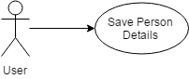

Figure 1 Use Case for adding new contact

Class Diagrams

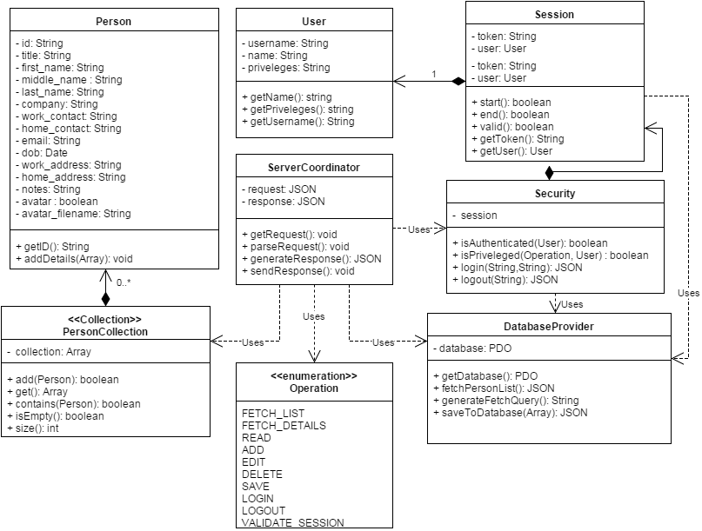
Figure 2 Class Diagram for add contact

Implementation

The main objective is to allow the user to save the contact details to the database. The implementation details are as follows:

- The save function is allowed only after the mandatory details are entered and the form is validated.
- The entered information is converted into a text/JSON form and sent to the server-side “ServerCoordinator.php”.
- The server-side script receives the text/JSON and parses it into a JSON object.
- The SQL query for adding the contact details to the database is prepared by mapping the fields to the JSON object.
- The SQL query is executed and the appropriate success/failure messages are passed to the client.

Files
3.1.1 JAVASCRIPT

File | scripts/js/Main.js
Description | This class creates the objects for the application and sets up the click and submit events. It directly deals with UI elements to implement business logic.
Pseudo Code | personDetailsForm.submit(function(event){  //serialize form information into JSON  var personJSON = $(this).serializeObject();  //duplicate record check  var duplicateFound = false;  persons.forEach(function(person){  // do not compare with self record  if(person.id != personJSON.id){  if(person.isDuplicate( pSON.email, pJSON.workContact)){  duplicateFound = true;  }  }  });  if(duplicateFound){  //show a that given email/workContact already exists  $('#message').html(message);  }else{  var personObj = new Person(personJSON.id);  personObj.addDetails(personJSON);  persons.add(personObj);  personDetailsDialog.close();  }  //repopulate list  populatePersons(persons, container, personDetailsDialog );  });

3.1.4 PHP

File | scripts/php/Security.php
Description | This is the php script that has the function login() which receives the encrypted username and password. It connects to the MySQL database and matches the credentials from the database. On unsuccessful authentication, it returns an appropriate error response.
Pseudo Code | function login(username, password){  new Request();  database = getDatabase();  SQL query = //get user with username and password  database.fetchResults();  if ( numResults == 0){  status = ‘failure’;  message( ‘Wrong username/password’ );  }elseif (numResults == 1){  status = ‘success’;  Message( ‘Welcome, ’ + NameOfUser );  }else{  status = ‘error’;  Message( ‘More than one user exists with the same username’)  }  response = generateResponse();  return response;  }  }
Passive (Yes/No) | Yes

File | scripts/php/DatabaseProvider.php
Description | This class is the provider of database and various procedures on the database.
Pseudo Code | function getDatabase(){  return this.database;  }
Passive (Yes/No) | Yes

File | scripts/php/PersonCollection.php
Description | This is the class that has the function login() which receives the encrypted username and password. It connects to the MySQL database and matches the credentials from the database. On unsuccessful authentication, it returns an appropriate error response.
Pseudo Code | function login(username, password){  new Request();  database = getDatabase();  SQL query = //get user with username and password  database.fetchResults();  if ( numResults == 0){  status = ‘failure’;  message( ‘Wrong username/password’ );  }elseif (numResults == 1){  status = ‘success’;  Message( ‘Welcome, ’ + NameOfUser );  }else{  status = ‘error’;  Message( ‘More than one user exists with the same username’)  }  response = generateResponse();  return response;  }  }
Passive (Yes/No) | Yes

File | scripts/php/Operation.php
Description | This class defines the constants by which the different operation are identified throughout application
Pseudo Code | abstract class Operation{  const FETCH_LIST = 'fetchList';  const FETCH_DETAILS = 'fetchDetails';  const READ = 'read';  const ADD = 'add';  const EDIT = 'edit';  const DELETE = 'delete';  const SAVE = 'save';  const LOGIN = 'login';  const LOGOUT = 'logout';  const VALIDATE_SESSION = 'validateSession';  }
Passive (Yes/No) | Yes

File | scripts/php/ServerCoordinator.php
Description | This class is responsible for getting operation requests and parsing the request. The appropriate response is generated and passed onto the UI client.
Pseudo Code | class ServerCoordinator{  private $request;  private $response;  function getRequest(){//.. do something }  function parseRequest(){ //.. do something}  function generateResponse(){//.. do something }  function sendResponse(){//.. do something }  }
Passive (Yes/No) | Yes

File | scripts/php/Session.php
Description | This class is the representation of a real-time session when a user logs in to the application.
Pseudo Code | class Session{  private $token;  private $user;  function start();  function end();  function getToken();  function getUser();  }
Passive (Yes/No) | Yes

File | scripts/php/User.php
Description | This class is the representation of a real-time user on the server-side.
Pseudo Code | class User{  private $username;  private $name;  private $priveleges;  function getUsername();  function getName();  function getPriveleges();  }
Passive (Yes/No) | Yes

Testing Considerations
Navigate to the home.html and follow the steps given below for each test case.

#Test Cases | Test Steps | Expected Results
TC 1 | - Click on the add button  - Click on the submit button | The details are not sent over to the server. The required fields are highlighted and the user is asked to fill up these details.
TC 2 | - Click on the add button  - Enter valid input  - Click on submit button | A message shows saying the given user has been added. The given contact details are added to the database and can be confirmed by the MySQL admin.
TC 3 | - Click on the add button  - Enter valid input  - Enter work contact or email address that already exists in the database  - Click on submit button | An error message displays saying “The provided work contact number and/or email already exist in the database.”
TC 4 | - Click on the add button  - Enter valid input  - Shutdown MySQL server  - Click on submit button | An error message displays saying “Cannot process your request. Please try again later.”

Screenshots

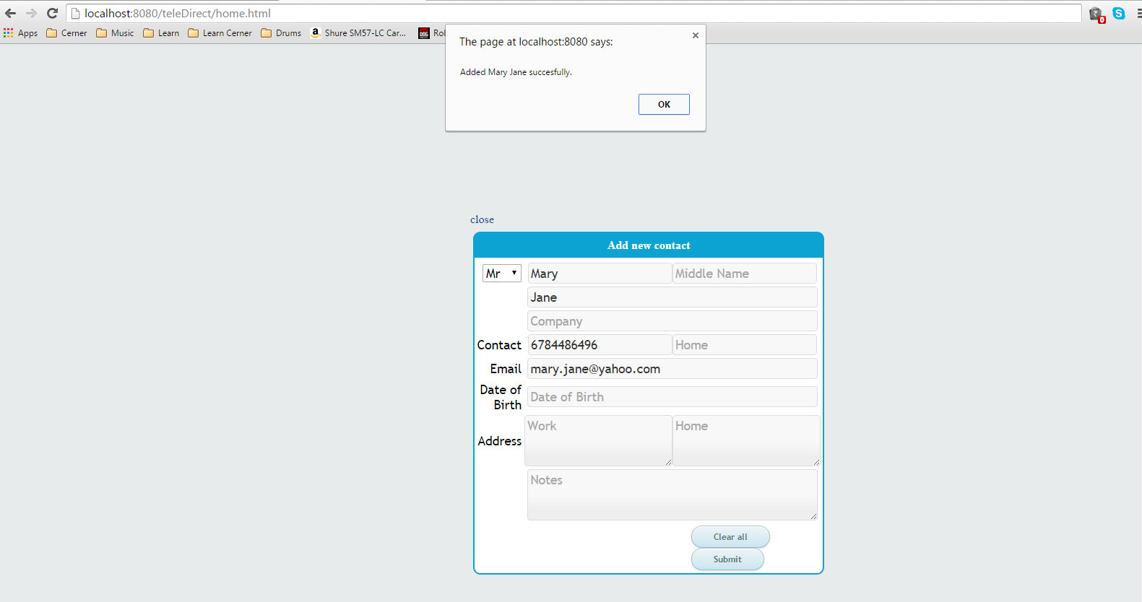
Figure 3 Saved new contact successfully

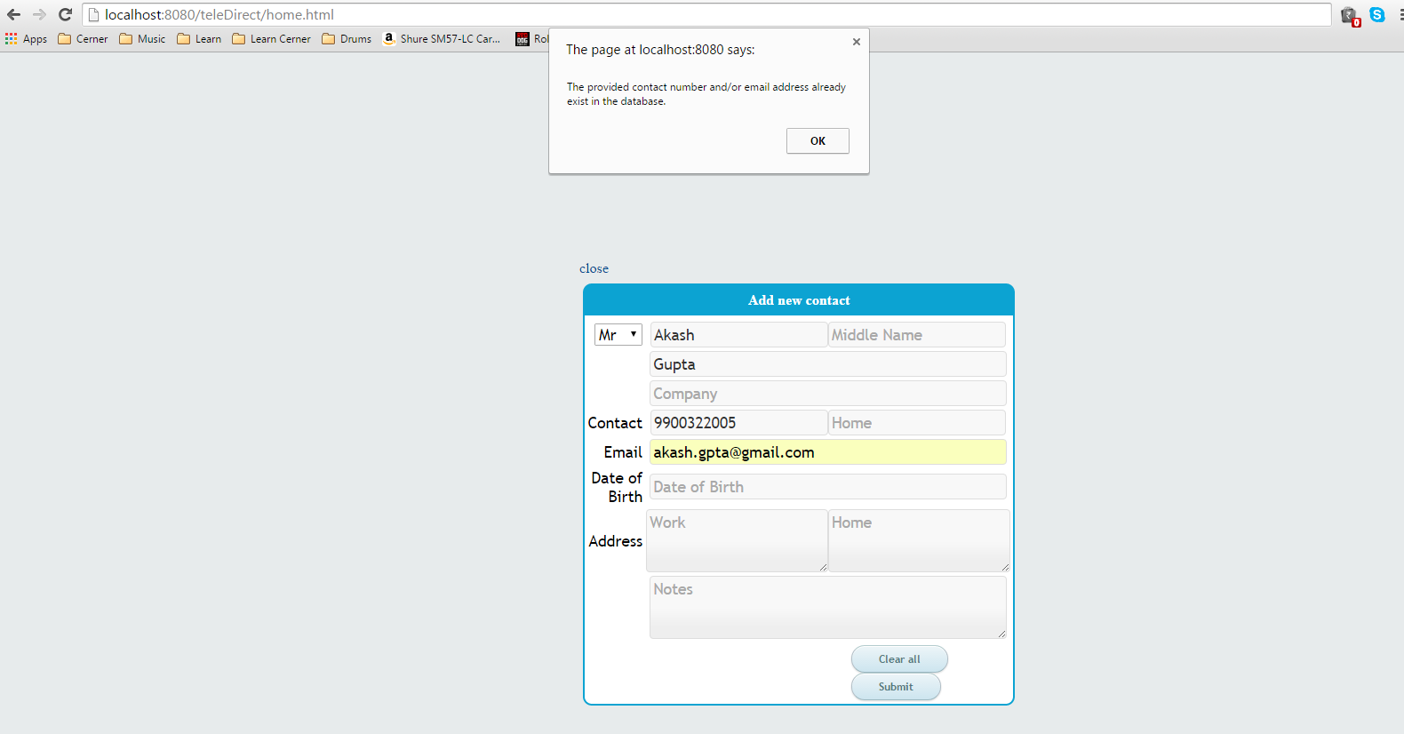
Figure 4 Could not add duplicate contact

